NAME____________________________LAB MEETING DAY/TIME______________

Lab 8: Proterozoic and Paleozoic North america

In this lab you will continue to examine geologic maps and explore the development of the North American continent in the Proterozoic and Paleozoic. You will be completing Exercises 14 and 15 in your lab manual.

# **Exercise 14, Part A**

**Answer the questions indicated below; you may skip questions 4, 5, 7, 9, and 10. The goal of this part is to refresh your memory on the building of the North American craton.**

**Question 1:**

**Question 2:**

**Question 3: Research “Abitibi Belt” online to answer this question. Also answer the question, what resource is found in this belt?**

**Question 6:**

**Question 8:**

# **Exercise 14, Part B**

**The goal of this part is to review the major sedimentary basins of North America.**

**Question 1:**

**Question 2: For this question, your TA will assign your group a basin/basins to research and report upon.**

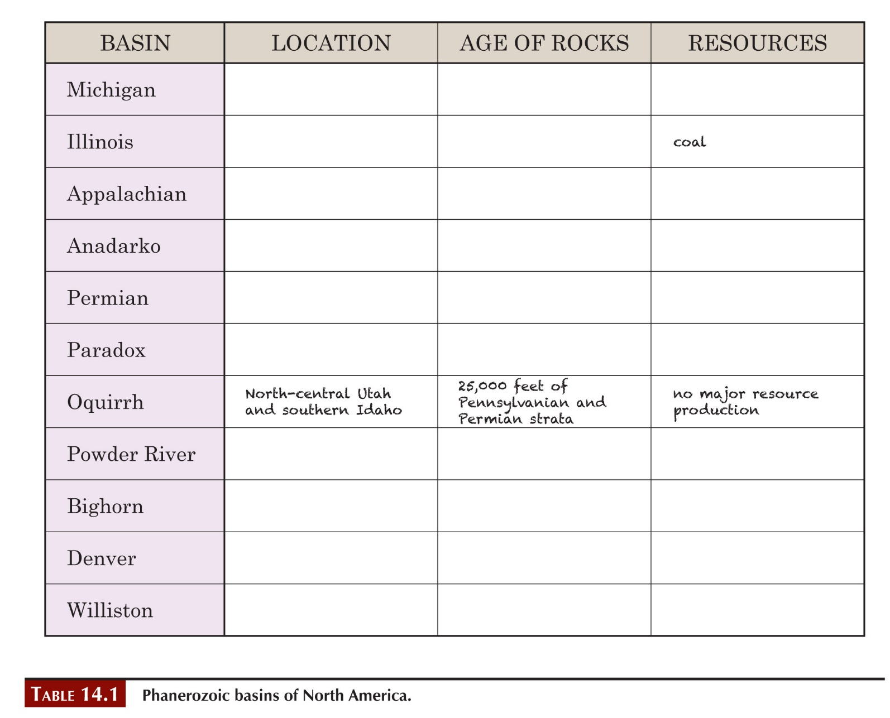

**Question 3:**

**Question 4:**

**Question 5:**

# **Exercise 15, Part A**

**Question 1:**

**Question 2:**

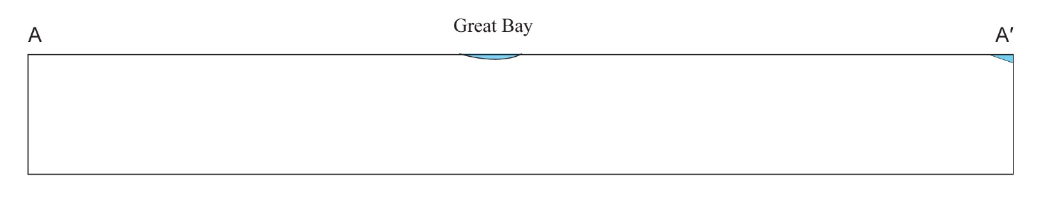

**SKIP QUESTION 3**

*The answer is that we cannot determine the fault type from the information given.*

**Question 4:**

**Question 5:**

# **Exercise 15, Part B**

**Question 1: The table is completed here for you. Take a minute to review this before moving on to the next question.**

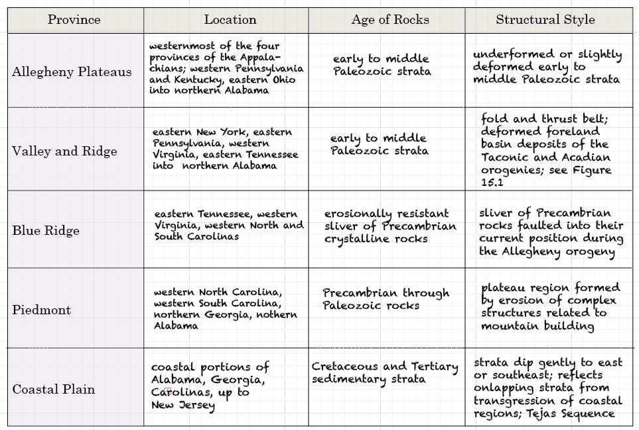

**Question 2: The map below is lightened from the one in your text, to allow easier drawing of the provinces.**

# **Exercise 15, Part C**

**Question 1: These formations are deposits from eroded rocks of mountains. Think about the orogenies of the Paleozoic, and decide which orogeny made the mountains that are the source area for the formations in the question. You might find it helpful to review the timing and location of major Paleozoic orogenies in your textbook (page 197, figure 10.3)..**

**Question 2:**

**Question 3:**

**Question 4:**

**SKIP QUESTION 5, the answer is that the river formed much later, after erosion of the folded rocks.**

**Question 6:**

# **Exercise 15, Part D**

**Question 1: For this question, review Figure 15.5 to understand the layering of rocks, but in the cross section below, draw the relationships between the Precambrian, Mesozoic, and Permian rock. In other words you don’t have to draw the individual layers of rocks.**

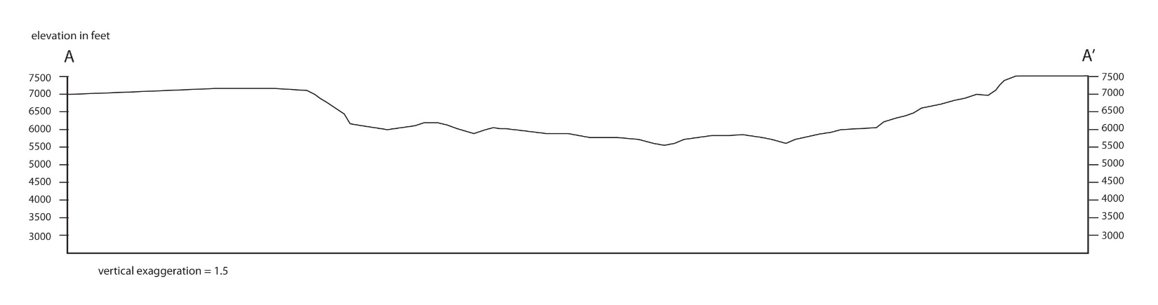

**Question 2:**

**Question 3: In other words, what might be a reason there are no Permian rocks between the Precambrian rock sand the Mesozoic strata? What might have caused this unconformity?**

**SKIP Question 4**

**Question 5: Think about the rock units and their characteristics for this map and cross section. Put the following events in order, from oldest (9) to youngest (1).**

____ Cenozoic uplift and erosion

____ Deposition and subsequent erosion of early- to mid- Paleozoic strata

____ Precambrian mountain building

____ Quaternary sediment deposition

____ Deposition of Chinle and Moenkopi Formation

____ Erosion of Precambrian mountains

____ Deposition of Burrow Canyon formation

____ Deposition of alluvial Cutler Formation

____ Deposition of Jurassic strata

# **Lab 8 Reflection**

**What concepts were most difficult in today’s lab activities?**

**What concepts were easiest to grasp?**

**What questions did today’s activities make you think of? What do you want to learn more about?**